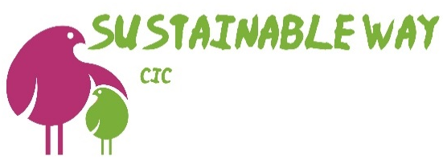
Uniform Request Form
Child’s surname | Postcode | Age | Sex | Build/height | School
Clothing item | Quantity  required | Colour preference | Size | Office use only  s/s updated | Office use only  w/l updated
polo shirt
s/s blouse or shirt
l/s blouse or shirt
Skirt
Dress
Culottes
Gingham dress/playsuit
School shorts
Trousers
Tank top
cardigan
Round neck jumper
v-neck jumper
Please provide contact details for delivery, this helps us to notify you when the uniform is ready.
email and/or mobile –

Completed forms can be emailed to uniforms@sustainable-way.org or handed in/posted to; The Green Way, 21 Leslie Street, Blairgowrie, PH10 6AH

